Hollywood PAL
APPLICANT INFORMATION
Name of Child:
Date of Birth: | Gender: (circle) Male Female |  | Phone:
Current address:
City: | State: |  | Zip code:
E-mail: |  |  | Nickname:
In school lunch program?: (circle) Yes No | Ethnicity: (Circle) African-American Armenian Asian  Caucasian Hispanic Other |  | School:
Grade: | Family Size:
PARENT OR GUARDIAN INFORMATION
Parent or Guardian Name:
Address (if different from above) : |  |  | Gender: (circle) Male Female
City: | State: |  | Zip Code:
E-mail: |  |  | Family Income:
Home Phone: | Cell Phone: |  | Work Phone:
Employer: | Title: |  | Occupation:
Other parent (or guardian) |  |  | Authorized for pick-up: (Y) (N)
SPOUSE OR GUARDIAN
Name:
Address (if different from above) : |  |  | Gender: (circle) Male Female
City: | State: |  | Zip Code:
Home Phone: | Cell Phone: |  | Work Phone:
Employer: | Title: |  | Occupation:
EMERGENCY CONTACT AND MEDICAL
Name of relative/friend:
Phone:
Relationship to child:
Insurance Company: |  | Policy Number:
Doctor: |  | Doctor's Phone:
Medical Conditions:
Allergies? Medication?
Paid: Date
Immunization: | Birth Cert.: | Identification: |  | Grades:
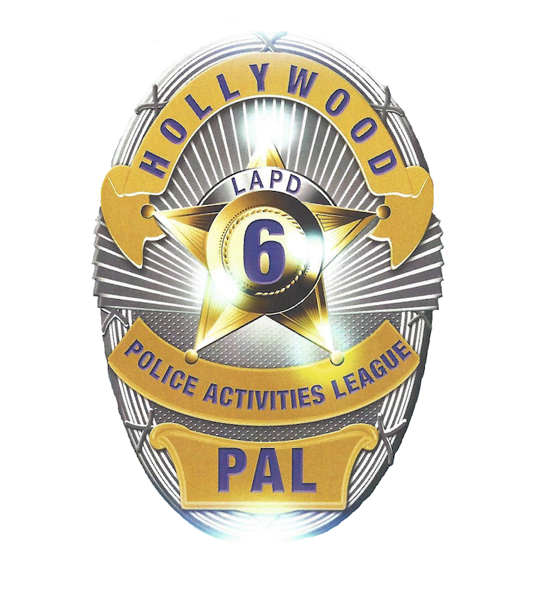

SIGNATURES
In consideration of the acceptance of my child in the educational programs of the Police Activities League (PAL), the undersigned parent (s)/legal guardian (s) of the Student consent to the participation of the Student in PAL activities and programs and release PAL from any liability, damage or loss that may be associated with or which may arise out of the student’s participation therein, as follows:
1. Consent
A. PAL Activities and Special Events: (1) The day-to-day activities of PAL, which are part of the student’s curriculum, and (2) Special events
at, or concerning, PAL. “Special Events” shall mean all other scheduled events or projects that are not necessarily part of the Student’s
general activities, or which do not fall within the categories of sports activities or field trips.
B. Sports: This consent applies to the Student’s involvement in such sporting activities, whether as an active participant in the sport or not,
or as a spectator, and this consent further extends to travel to and from the location of such sporting activities.
C. Field Trips: Field trips associated with, or arranged by PAL. For purposes hereof, “field trips,” outings or visits to locations other than any
of the PAL locations for educational, cultural, social, political or other beneficial purposes, including but not limited to museums, historical sites, concerts, and other educational facilities, factories or other industrial facilities, banks or corporations and other commercial enterprises, and more. I also give full authorization for my child to participate in all field trips that are a part of the planned activities and program of PAL.
2. Release
A. Special Claims: The undersigned release (s) PAL, its affiliates, officers, directors, shareholders, employees, attorneys, agents,
representatives, predecessors, successors and assigns and all others acting by, through or under same, from any liabilities, damage or loss that may occur due to or arising out of the matters described in Section 1 above, regardless of whether such damage or loss is the nature of a personal injury, happening to the Student, or happening to another caused by the Student, or as property damage, regardless of whatever extent or degree.
B. Medical Release: In the event that my child becomes ill or sustains an injury while in the care of PAL, I understand that every effort will
be made to contact the parent (s) or legal guardian (s). If it is not possible to reach me or the physician named above to receive instructions for his/her care, consent is given to any licensed physician and/or surgeon called for or to whom the child is taken for treatment by them, to administer drugs or medicines and to perform such surgical procedures as he shall think the existing emergency requires for the relief of
pain and to preserve his/her life and health.
C. Photo Release: Due to the non-profit nature of the PAL program, I understand that photos, artwork or video of children may be used for
promotional purposes, whether in written, electronic (website) or other forms. I thereby give my consent to use photos of my child for this limited purpose. Furthermore, I hereby consent that such information, photographs, videos, and/or tapes from which they are made shall be PAL property, and PAL shall have the right to sell, duplicate, reproduce and make other uses of such information, photographs, videos, and recordings as they may desire free and clear of any claim whatsoever on my part.
I/We have carefully read this consent and release agreement and have given PAL the correct information on the front of this form. I/We
agree to update this information as needed and fully understand its contents. I am aware that this is a release of liability, including any claims not now known to me, and that it is a contract between myself and the Police Activities League Program, and/or its affiliated organizations, and I/We sign the document voluntarily.
Signature of parent or guardian: | Date:
Signature of child: | Date:
Uniform Size:  Shirt (circle one): Kids Small Kids Medium Kids Large  Adults Small Adults Medium Adults Large  Shorts (circle one): Kids Small Kids Medium Kids Large  Adults Small Adults Medium Adults Large | For Office Use:  DATE RECEIVED:  PAID:

