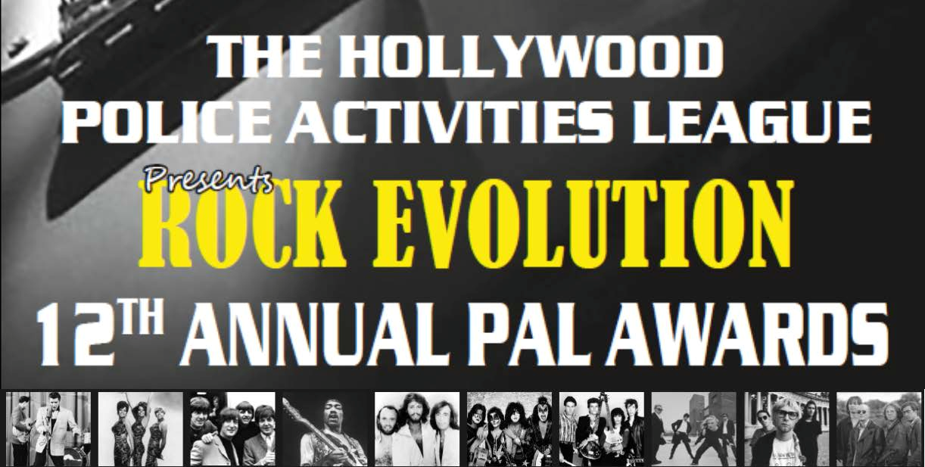

PAL AWARDS AUCTION DONATION & ADVERTISMENTS
The LAPD Hollywood Police Activities League invites you to attend The 13th Annual PAL Awards: HAVANA NIGHTS,
on Wednesday, October 5th, 2016 at the Taglyan Cultural Center, Hollywood, 6:00PM. This premiere live music event will
raise essential funds for Hollywood’s leading crime prevention and youth services organization.

DONOR NAME (to be listed):

CONTACT PERSON:
PHONE:

ADDRESS:

EMAIL:

◻ Auction Item Donation

ITEM DESCRIPTION:

◻ Item to be delivered ◻ Item to be picked-up

VALUE:

◻ Please send me information about other Sponsorship Opportunities

Completed forms should be emailed or mailed to: Hollywood PAL
1358 N. Wilcox Avenue Los Angeles, CA 90028 kwiener@hollywoodpal.org/ (323) 467 7114

The Hollywood Police Activities League is a 501(c)3 non-profit organization with federal tax ID #95-4596172.
Donations are tax deductible to the extent allowed by law. www.hollywoodpal.org
Hollywood Police Activities League ♦ 1358 N. Wilcox Ave/6501 Fountain Ave ♦ Los Angeles, CA 90028
PH: 323.467.7114 ♦ info@hollywoodpal.org ♦ www.hollywoodpal.org

